Customizing a JUICE mini-lesson

Table of Contents

Overview—parts of a mini-lesson (modulette) 2

S3 file structure reminder 4

Editing a mini-lesson (modulette) 5

Editing modulette tabs 11

Editing modulette tracks 14

Adding and removing mini-lessons (modulette) 18

Removing a mini-lesson 18

Adding a new mini-lesson 18

Adding and removing modulette tabs 19

Removing a modulette tab 19

Adding a tab to a modulette 20

Adding and removing tracks from a tab 20

Removing tracks 21

Adding tracks 23

# Overview—parts of a mini-lesson (modulette)

A mini-lesson is called a “modulette” in the JUICE back end. A modulette consists of the following components, each of which correspond to elements in the UI:

| **Component** | **What it is** | **How it looks** |
| --- | --- | --- |
| tabs | Mini-lesson parts   Modulettes may have 1, 2, or 3 tabs, each of which can offer a different style of content presentation.  Currently the tab names are hard coded as shown in the screen shots below. If a modulette only has one tab, the tab will still show in the UI. |  |
| tracks | Mini-lesson part choices  Each tab can display one or more content choices or tracks.   If a tab has more than one track, a “choose” page showing the different tracks displays. If a tab has only one track, the “choose” page does not display. |  |
| widgets | Content players  Each modulette track has an associated widget that defines the type of content player the track will use.  JUICE currently has 13 widgets—Overview (Refresher), Try it (Guided Practice), and 11 game widgets. | Guided Practice widget    Balancer widget |
| files | Learning content  Learning content files contain text and links that are rendered by the widgets. |  |

The information about how the modulette should look, what widgets it should use, and what files it should play are stored in a file in the modulette’s directory called **modulette.txt**.

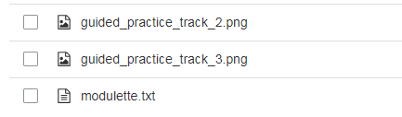

You may update the modulette’s contents by editing the **modulette.txt** file. This document describes how to modify the tabs and tracks that comprise a modulette’s pages, as well as the widgets and content files associated with the modulette’s tracks.

IMPORTANT! Content-related changes made in **modulette.txt**, such as modifying the modulette’s title, will only be reflected on that modulette’s Overview, Try it, and Challenge game pages.

To make content changes to the JUICE dashboard, you must edit the **modules.txt** file. To make changes to a module, you must edit the appropriate **module.txt** file.

For example, if you change the name of a modulette by editing the “title” field of **modulette.txt**, the new name will appear on the corresponding modulette pages (Overview, Try it, and Challenge game pages), but will not appear on the JUICE dashboard, or the JUICE module page unless you also change the **modules.txt** and **module.txt** files.

## S3 file structure reminder

Module and modulette ids correspond to directory names in S3. For example,

* The files for module QS1 are found in the S3 directory QS1.
* The files for modulette QS1.1 re found in the S3 directory QS1/1.

Files for alternate (custom) programs are found in the specific alternate program’s directory, which is located in /programs.

Note that S3 uses the forward slash (/) for path names rather than the DOS backslash (\).

# Editing a mini-lesson (modulette)

To edit an existing modulette:

1. Go to S3 and open the module folder containing the mini-lesson (modulette) you want to edit. Folders are identified by their module ID.

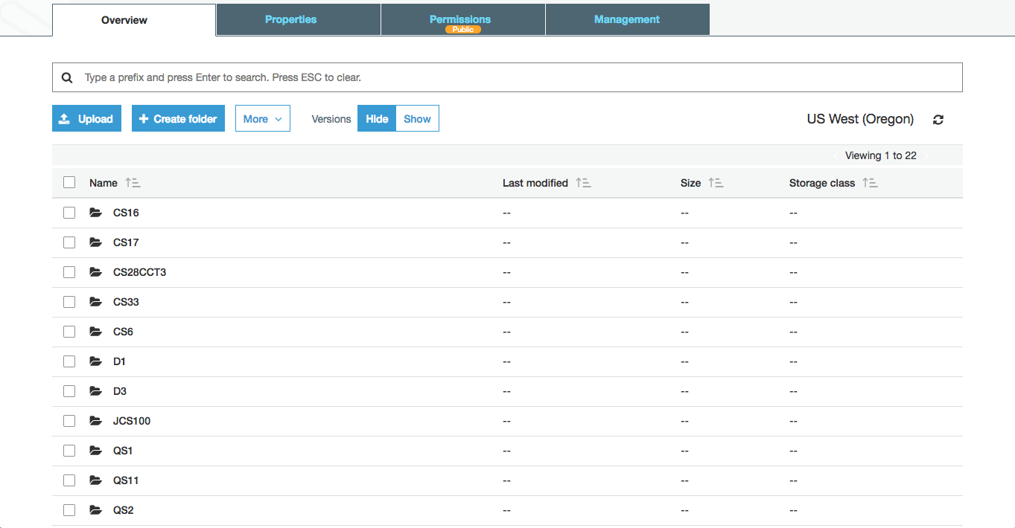

Inside the module folder, you will see numbered sub-folders. There is one folder for each of the modulettes included in the module. The number of the folder corresponds to the number portion of a modulette’s id.

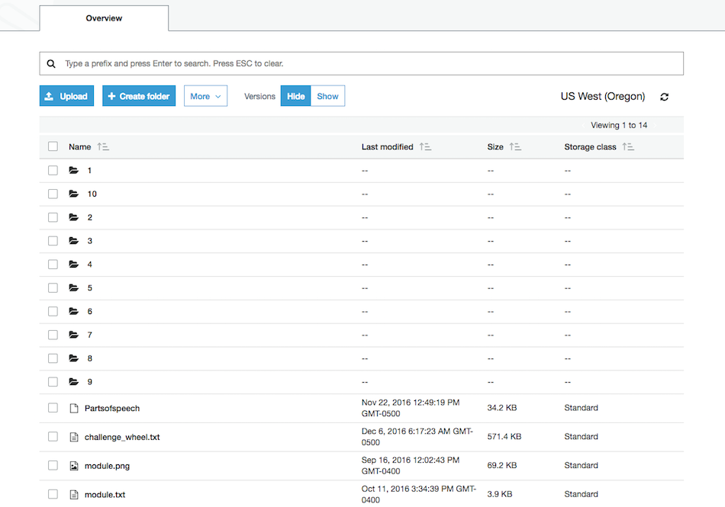

1. Open the numbered folder corresponding to the modulette that you would like to edit and find the modulette.txt file. Select the checkbox next to the file, then click the download button. Open the downloaded modulette.txt file with Brackets or other structured text editing program.

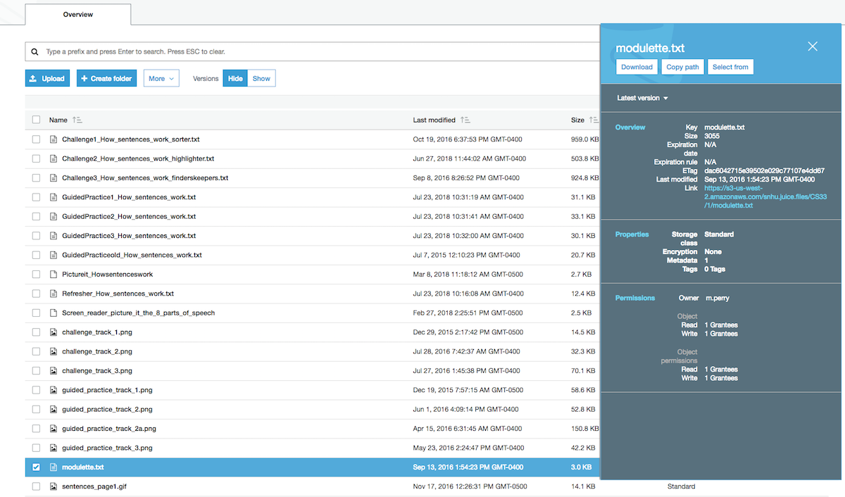

1. The opened file will look something like this. To change the modulette, edit the values associated with the appropriate json parameters. See the table below for details:

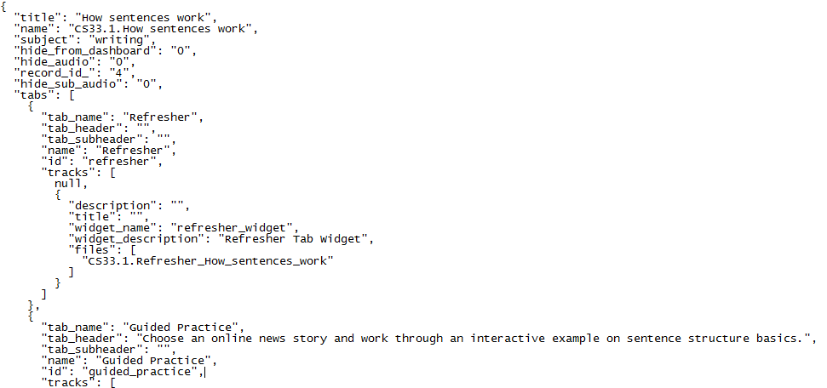

| **json parameter** | **Notes** |
| --- | --- |
| title | This is the display title for the site.    If you change this value in **modulette.txt**, you must change the modulette link name in **modules.txt**, and modulette title in **modules.txt,** as well as update the Mongo DB Search tables so that the modulette title matches throughout the site. See the document *Using tags to improve JUICE Search* for more information about updating Search. |
| name | This is the modulette’s complete identifier. It has two parts: the modulette ID, which includes the module id, and a brief text description.  The modulette ID portion of this identifier is used by the JUICE application to identify and load the modulette, and is also used in student activity data.  Example: **QS11.1.Distance, rate, and time**  **QS11.1** is the id used to identify this modulette. **QS11** is the module, and **1** is the number of the modulette within the module. **QS11.1** is the first mini-lesson in module QS11.  The number “1” must correspond to the S3 directory name of the modulette within the module directory.  The files for modulette QS11.1 are in S3 directory QS11 / 1  It is recommended as a best practice to not edit the alpha-numeric part of an existing modulette’s ID. You may edit the text part. |
| subject | This controls the color of the broad bands behind the headers in the Overview and Try it content as well as the top of the modultte page.  The supported choices are “math” or “writing.” JUICE currently uses “writing” for anything non-quantitative. Writing is green, and math is blue |
| hide_from_dashboard | This is for informational purposes only and has no impact n the site.  You may hide an existing modulette from the dashboard. To do so, you set the “hide_from_dashboard” value in the **modules.txt** file. |
| hide_audio | Hides the the audio coach button from the top of the modulette page:    “hide_audio”: “1” will hide the audio icon. “hide_audio”: “0” will display it.  See the documentation *Adding and customizing narration* for more information. |
| record_id | This is the database record ID from JUICE’s original content management system. It is for information only and not used in the site. |
| hide_sub_audio | Hides the the audio icon from the steps in the Overview:    “hide_audio”: “1” will hide the audio icon. “hide_audio”: “0” will display it.  See the documentation *Adding and customizing narration* for more information. |
| tabs | The next section of **modulette.txt** controls what tabs are displayed in the modulette. See below for more information. |

# Editing modulette tabs

Each mini-lesson has one or more tabs that offer different learning experiences. The Overview tab typically offers a step-by-step presentation, the Try it tab offers an interactive version of the Overview, and the Challenge Games tab offers game-based practice. The tabs are displayed in the order in which they are defined in **modulette.txt**.

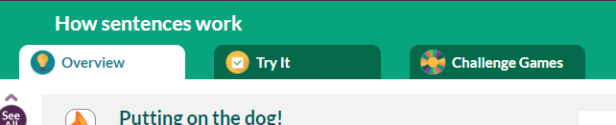

You may update the appearance and contents of the tabs by editing the tabs section of **modulette.txt**.

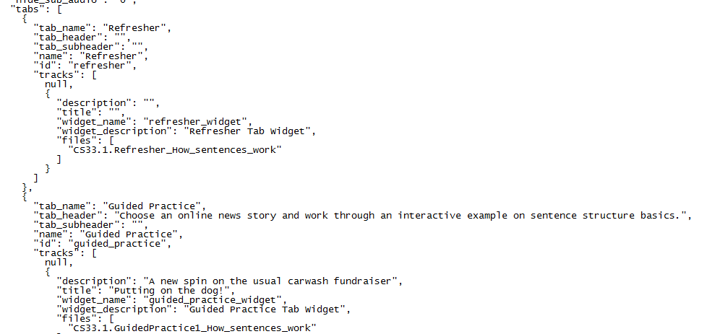

| **json parameter** | **Notes** |
| --- | --- |
| tab_name | This field is a legacy field and does not impact the JUICE site.  If you wish to remove the tab_name value, delete the text inside of the quotation marks but do not remove the quotation marks:  "tab_name": "" |
| tab_header | If your tab has more than one track or choice, it will show a “Choose” page that displays the choices.  The tab header appears in green type at the top of the Choose page:    If you do not supply a tab header, it will show the following defaults:  Overview: Choose from any of these examples to see an interactive refresher  Try its: Choose from any of these examples to see an interactive walkthrough  Challenge games: Play all three challenges to practice your skills. Pick any challenge to get started!  Note: In the current JUICE design, we only use one track for the Refresher / Overview tab, so the Choose page does not display. |
| tab_subheader | This text appears underneath the green header text on the Choose page. It is optional and rarely used.    This text supports HTML and can include links. |
| name | This field is a legacy field and does not impact the JUICE site.  If you wish to remove the name value, delete the text inside of the quotation marks but do not remove the quotation marks:  "name": "" |
| id | This controls the text and icon that displays on the tab. You cannot have two of the same id in the same modulette file.  If a tab does not have an id, its tracks and/or content will not load.  JUICE currently supports three values for id:  “refresher”  “guided_practice”  “challenge”  Choose the id that corresponds to the type of content file the tab plays.  If you enter an id other than the 3 supported, your content will still load, but the tab won’t have any text or icon to identify it.  Don’t use the “challenge” id on a tab that will play anything other than challenge game widgets. JUICE will not be able to load the non-game content. |
| tracks | This section of **tabs** defines the tracks available for each tab. It includes track descriptions, widget names, and the names of the content files.    See below for more information. |

# Editing modulette tracks

Each tab can have one or more “tracks” or choices of content files for the student to work through. The tracks are displayed in the order in which they are defined in **modulette.txt**. If there is only one track for an Overview or Try it tab, the track content displays when the tab is loaded. Otherwise, the site displays the tab’s “choose page.”

Each track includes a title, description and information about the widget and content files. You may update these by editing the parameters in the “tracks” section of “tabs.”



| **json parameter** | **Notes** |
| --- | --- |
| description | If there is more than one track, this text will appear on the “Choose” page. It is the gray text that appears underneath the track title.  Each track has its own editable description. |
| title | If there is more than one track, this text will appear on the “Choose” page. It is the text in green underneath the track image:  Each track has its own editable title.    If neither description or title are filled in, the site will show nothing. |
| widget_name | This value controls which widget type the track will load.  For Overview (Refresher) tracks:  refresher_widget  For Try it (Guided Practice) tracks:  guided_practice_widget  For game tracks:  balancer_widget  finders_keepers_widget  fix_it_widget  fridge_magnets_widget  highlighter_widget  perfect_word_widget  pick_and_stack_widget  puzzler_widget  quick_pick_widget  sorter_widget  stacker_widget  You shouldn’t modify an existing widget name unless you also plan to replace the content file with one created for the widget type you are swapping in. Modifying or removing the widget_name can break the track.  Examples of what can go wrong:  Deleting this value from a refresher track creates an infinite loading screen. Modifying the value to something other than a known widget type will load a blank screen.  Changing a guided practice to use refresher_widget will cause the track to load the text of the guided practice file, but none of the question interactions.  Changing a refresher to use the guided practice widget will cause the track to load the refresher file, but the steps may be out of order or render incorrectly.  For games, changing the widget_name to another type of game widget, or to refresher_widget or guided_practice_widget, will result in the game content not loading and an error message on the JUICE site. |
| widget_description | This field is informational only. It has no impact on the site  For games, this will be the name of the game type. “Finders Keeper”, for example.  For refreshers and guided practices it will be “Refresher Tab Widget” or “Guided Practice Tab Widget”. |
| files | This field tells the widget player which content file to load. It should include the location of the file in the S3 directory structure represented using dots for slashes, as well as the exact file name.  Example: **CS33.1.Refresher_How_sentences_work**  This file is in S3 directory **CS33 / 1** and its exact name is Refresher_How_sentences_work. You are not required to include the extension with the file name.  You shouldn’t need to edit this field unless you plan on using a new or different file with the track.  If you do plan on customizing and/or creating new mini-lesson files, see document *Customizing and creating new mini-lesson files* for details on file naming conventions and authoring. |

# Adding and removing mini-lessons (modulette)

## Removing a mini-lesson

To remove a modulette from your JUICE program, delete the modulette’s directory in S3, and edit the files **module.txt** and **modules.txt** document to remove the modulette from its module, and from the JUICE Dashboard. See the documents *Customizing the JUICE Dashboard* and *Customizing a JUICE module* for more information. You must also edit the Search tables in Mongo DB so that the modulette is no longer available as a search result. See the document *Using tags to improve JUICE Search* for more information about updating Search.

## Adding a new mini-lesson

To create a new mini-lesson:

1. Open the module directory where you want the new mini-lesson to appear and click the “Create Folder” button.
2. Enter the mini-lesson ID as the folder name. The mini-lesson ID will be the number of the mini-lesson. For example, if you are creating the first mini-lesson in a module its ID will be 1. If you are creating the 12th mini-lesson, its ID will be 12.

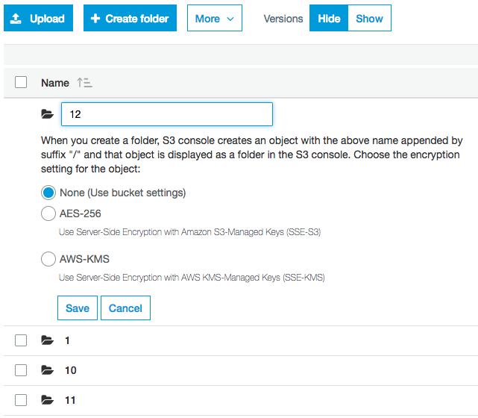

1. Click Save. This will create a new empty mini-lesson.
2. To populate the mini-lesson directory with content, download a **modulette.txt** file from an existing JUICE mini-lesson directory and open it with Brackets or other structured text editing program.
3. Edit it as desired.
4. Upload the edited **modulette.txt** file into the new modulette’s directory.
5. Edit the **module.txt** and **modules.txt** files to add your new modulette to its module page, the program’s dashboard and edit the search tables in Mongo DB to make it available to Search. See the document *Using tags to improve JUICE Search* for more information about updating Search.
6. Add modulette images and content files. See the documentation *Customizing and creating new mini-lesson files* for more information.

# Adding and removing modulette tabs

## Removing a modulette tab

If you want to remove a tab or tabs from a modulette, edit **modulette.txt** to delete the section that defines the tab and its tracks.  
  
Locate the tab you wish to delete. Delete the open bracket on the line above the “tab_name”, and continue deleting until you reach the open bracket preceding the next tab’s section.

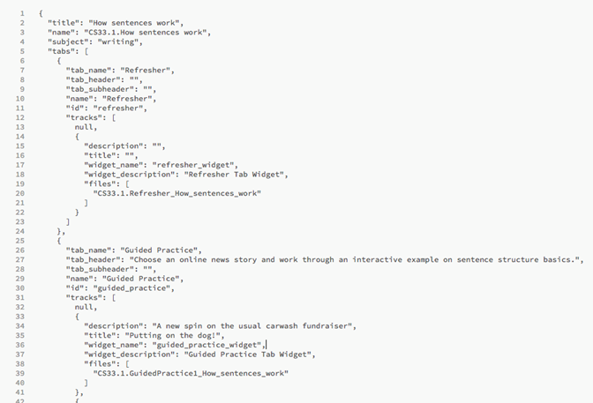

In the image above, the circled section represents the Overview/refresher tab of the modulette and the track and content nested under the tab. Deleting the text within the circle will remove that tab, but preserve the other two tabs in the modulette.

## Adding a tab to a modulette

If you want to add a new tab to a modulette, copy the information for an existing tab in the **modulette.tx**t file and insert it into the correct location in the file. The order of the tab information in the file should be the same as the order in which you want the tabs to appear on the site. Edit the copied tab information as needed.

CAUTION! You may have a maximum of three tabs in a modulette. Also, you may not have two tabs with the same tab type. For example, you may not have two refresher tabs.

# Adding and removing tracks from a tab

## Removing tracks

If you want to remove a track or tracks from the modulette, edit modulette.txt to delete the section that defines the track.

Locate the track you wish to delete. Delete the open bracket on the line above the tack’s “description”, and continue deleting until you reach the open bracket preceding the next track’s section.

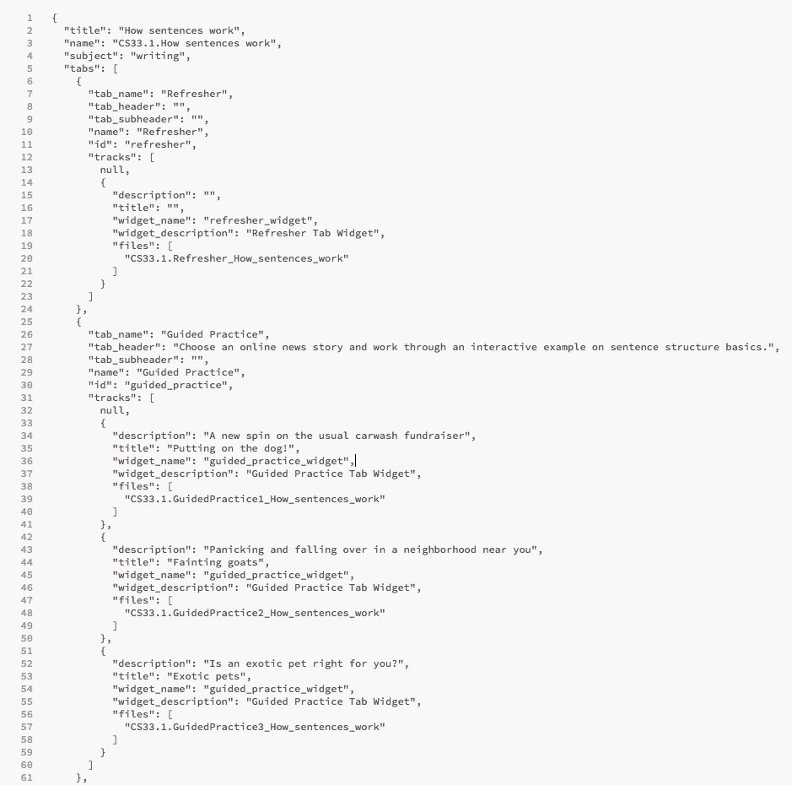

In the image above, the circled section represents the first track of the guided practice tab of the modulette. Deleting the text within the circle will remove the first track, but preserve the other two tracks on the tab.

## Adding tracks

If you want to add a new track to a tab, follow the same steps but copy the lines controlling the track and paste them in the order you want the tab to appear on the modulette. Then, modify the track’s fields for your program, based on the descriptions in the previous table.

If you want to add a new track to a tab, copy the information for an existing track in the **modulette.tx**t file and insert it into the correct location in the file. The order of the track information in the file should be the same as the order in which you want the tracks to appear on the tab in the site. Edit the copied track information as needed.

You may have as many tracks on a tab as you like.